

BRON & RUSEVAL CABERNET 2024

IGT FORLI
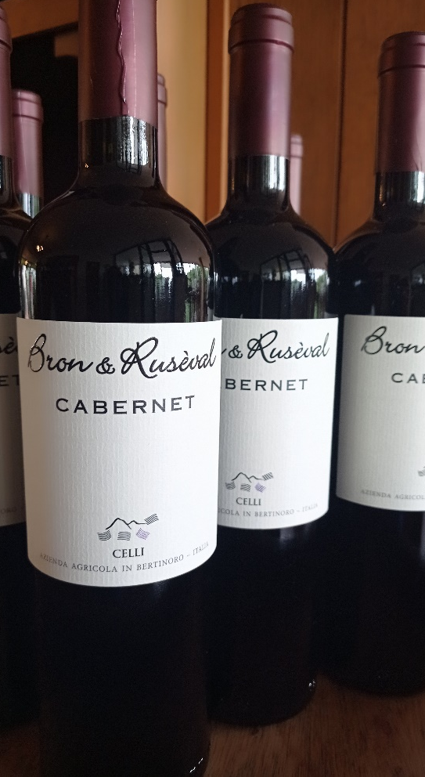

TECHNICAL FEATURES
Grapes 100% Cabernet Sauvignon
Area of origin Bertinoro
Vineyards Maestrina
Bottles produced 6,000
Vine-grown surface 2.40 ha
Exposure north-east
Soil clayey mixture, with high presence of active
limestone
Oenologist Andrea Calisesi
Planting density 5000 plants per hectare
Production per hectare 8 ton grapes, 55.22 hl wine
Colour Ruby red, thick and full with violet nuances
Bouquet Strong with red-berry fruit scents, blackberry,
well balanced with liquorice scent
Taste Good structure, though agile in the mouth
Aging in stainless steel tanks, then refining in bottle
Food matching Grilled red meat, poultry

ANALYTICAL FEATURES:
Alcohol 13 % vol.
Volatile acidity 0.50 g/l
Total acidity 5.80 g/l
Net dry extract 32.5 g/l
Residual sugars traces
Sulphurous 70 mg l
Free sulphurous 20 mg/l

In Romagna people were accustomed to give a nickname to the peasant families that was then handed down from father to son, a tradition which, similarly to our dialect, is going to die.
“Bron” and “Rusèval” were and will be the nicknames of the families Sirri and Casadei respectively.
Producing a good quality wine and identifying it with this name is a unique occasion to continue a tradition that would have hardly survived over the time. The project was born years ago when the farm decided to test the potential capacities of its lands as well as its technical abilities with international grapes like the Chardonnay and the Cabernet.

2024 VINTAGE FEATURES
The 2024 harvest brought a series of new projects to the winery in pursuit of grape purity. After the new Albana Bron&Ruseval, we chose to vinify the Bron&Ruseval Cabernet (previously 60% Sangiovese and 40% Cabernet Sauvignon) as a single varietal.
The winemaking style has also changed: fermentation in stainless steel, without the use of wood.
The result is a well-structured wine that has preserved its fruit, dense yet smooth, full-bodied yet easy to drink. We are definitely satisfied with the result!

